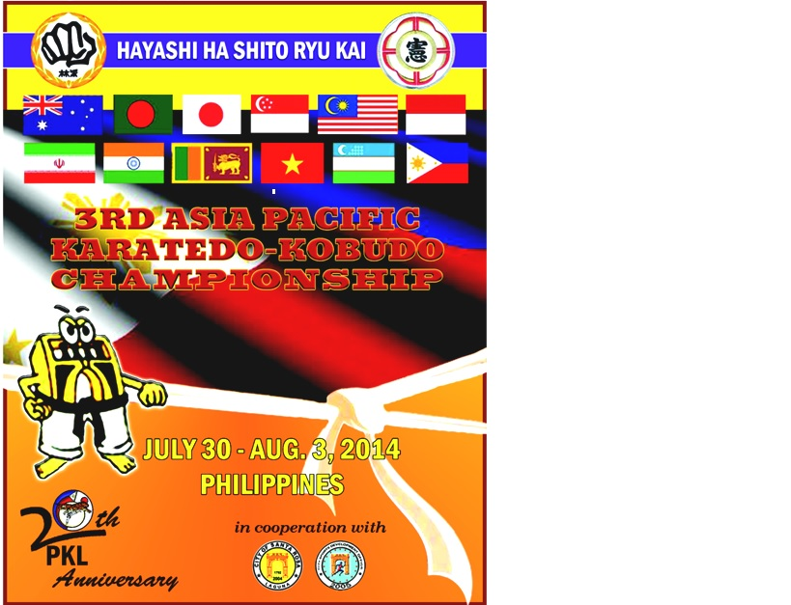

3RD ASIA PACIFIC HAYASHIHA SHITORYUKAIKARATEDO AND KOBUDO TOURNAMENT AND TRAINING CAMP
OFFICIAL INVITATION

Philippine Karatedo League
HAYASHIHA SHITORYUKAI PHILIPPINES

Dear Colleagues,

Greetings of Peace!

The Hayashiha Shitoryukai Philippines and Philippine Karatedo League, official host of 3rd AsPac Hayashiha Shitoryukai Karatedo and Kobudo Tournament and Training Camp to be held on July 30-August 4, 2014 at Filinvest, Alabang, Muntinlupa City, PHILIPPINES.

I feel glad and proud that our Hayashiha Shitoryukai Karate Family from different Asia Pacific Regions will gather in one big event this year. We are sure to offer you a high quality tournament and seminar.

We are looking forward to meet you all and having a wonderful time with you here in the PHILIPPINES.

Thank you very much and God bless us all!

Very truly yours,

DAVY QUEANO AQUINO
Country Head
Hayashiha Shitoryukai Philippines

3RD ASIA PACIFIC HAYASHIHA SHITORYUKAI
KARATEDO AND KOBUDO TOURNAMENT AND TRAINING CAMP
GENERAL RULES AND REGULATIONS
1.RULES
The 3RD ASIA PACIFIC HAYASHIHA SHITORYUKAI KARATEDO AND KOBUDO TOURNAMENT AND TRAINING CAMP will be conducted in accordance with the New Rules (version 8.0) of the world karate federation (WKF), which was adopted on January 2013 for Juniors & Cadets, whereby for children under 16 years will be adopted HAYASHI HA SHITO RYU KAI JAPAN RULES .
In case of a disagreement in the interpretation of rules, the English text of the rules shall prevail. Any
unforeseen incident not covered by the Rules shall be death with accordingly in the following manner:

  - Technical questions shall be resolved in accordance with WKF rules
  - Cases of general nature shall be resolved in accordance with the WKF statues and rules (2013)

- DATE:
July 30-August 4, 2014

- VENUE:
Festival Super Mall, Filinvest, Alabang, Muntinlupa City, Philippines

- Events:
As attached in appendix A

- Accommodation & Transfer:
As attached in appendix B

COMPETITION SCHEDULE

30 July 2014-Arrival and Registration
Exhibits Opening
31 July 2014-SEMINAR

- Registration of Participants
- Kobudo Seminar-1:00pm
- Karate Seminar - 2:30-5:00pm
- Welcome Cocktail-6:30pm (Delegation Officials and Dignitaries) to be confirmed
01 August 2014-SEMINAR AND CONGRESS
- Referee & Refreshers Course
- Official Drawing of lots
- Training Camp at the Tournament Venue
- Coaches and Managers Meeting
- ASPAC Congress Meeting
02 August 2014-TOURNAMENT (ELIMINATIONS AND SEMI-FINALS) 9:00AM-800PM-Festival Super Mall, Filinvest, Alabang, Muntinlupa City
- All Categories
- Kobudo Championship

- August 2014: TOURNAMENT (CHAMPIONSHIP)
All Finales-10:00-5:PM-Festival Super Mall, Filinvest, Alabang, Muntinlupa City

a. ALL CATEGORIES
b. SAYONARA PARTY-6:30PM-Crimson Hotel GRANDBALLROOM

- VICTORY CEREMONIES:

  - Victory Ceremony
The Victory Ceremonies shall normally be held after the completion of event.
  - Prices
First Prize : Gold Medals and Diplomas to the first winner in each category.
Second Prize: Silver Medals and diplomas to contestant placed in the second in each category.
Third Prize: Two Bronze Medals and diplomas to the losing semi-finalist in each category.

- CLOSING DATE:

  - The closing date for all entries will be on 15 JUNE 2014.
  - The Organizing Committee wish to have your reply on participation, once you have received the championship details. (Email-karatedopklway@yahoo.com) Attn: Sensei Davy Q. Aquino

COMPETITION REGULATION
- TECHNICAL ORGANIZATION
The Hayashi ha Shito ryukai Japan is responsible for and full control of the technical
organization of the karate competition, in consultation with the international technical
delegates when necessary.

- DRAWING OF LOTS
The drawing of lots will be conducted by officials appointed by Organizing Committee
for karate the draw will be computerized.

- DURATION OF BOUT
The official duration of kumite matches will be three (3) minutes for men, two (2)
minutes for women, Junior, Cadet &12/13 years old for under 12 years will be 1.5

- DRESS CODE
All contestant and team officials (coaches, managers, etc), referees and judges must
wear the prescribed uniforms as defined in appendix 1 of the WKF rules .

- EXPENSES

  - Participation Fees:
USD60 per contestant (maximum 2 individual categories)
USD80 per team (kata/kumite)

  - Air fare – each participant is responsible for airline ticket
  - Referees Seminar-USD 50 per pax
*Fees for referees seminar will only be waived for WKF Qualified Referees*
Note: All referees are required to attend the Referee Refreshers Clinic
Fee: USD 30 per pax-to all referee refreshers participants
5.4 Karate Seminar- USD50 per pax
5.5 Kobudo Seminar-USD50 per pax
5.6 Karate & Kobudo Seminar -USD 80 per pax
5.7 Karate,Kobudo & Referee Seminar-USD100 per pax
5.8 Sayonara Party-USD 50 per pax

- SAFETY EQUIPMENT
6.1 Mitts, foot protection and mouth guards are compulsory.
6.2 Mitts, mouth Guards, belts and body protection (for women) shall be provided by the athletes themselves.
- HAYASHI HA SHITO RYU KAI COMPETITOIN REGULATION

  - All participants must be members of Hayashi ha Shitoryukai.
  - All entry forms and payments must be received by the Organizing Committee by the published closing date.
  - The competitor’s age must be the same as the age for the category entered on the year of competition.
  - Each country or region may enter any number of teams in each category, and any number of individuals.
  - All Kumite contestants must wear gum shields and must supply their own red and blue mitts and belts. Females should wear breast protectors. Shin and foot protection is compulsory but need not to be of WKF approved type so long as it safe and within reasonable dimensions.
  - All competitors are responsible for providing their own medical insurance.
The rules are the rules of the World Karate Federation, with some exceptions as to weights, ages and categories. For children the rules will be those of Hayashiha Shitoyukai Philippines. (Absolutely no face contact allowed).
  - Each participating country or group entered must supply referees or judges to work in the Championship. The actual number is required is dependent on the size of the delegation as follows; Up to 10 competitors- 2 referees or judges More Than 10 and up to 20 competitors – 3 referees or judges More than 20 competitors -4 referees or judges.
  - If they do not have a World Karate Federation, Continental, or Hayashi ha Shitoryukai Japan qualification, they must attend the Referee Course. All referess MUST attend the course.
Failure to comply may mean that their competitors will be unable to participate.
  - The person or persons organizing the entries for the groups competitor confirms that all competitors have been advised of the risks of competitor karate and that they fully realize and accept these risks.

APPENDIX (A)
KUMITE CATEGORIES
MALE CATEGORIES  Kumite |  | FEMALE CATEGORIES  Kumite
Boys Individual Kumite  6-7, 8-9, 10-11, 12-13 yrs.old |  | Girls Individual Kumite  6-7, 8-9, 10-11, 12-13 yrs.old
Cadet Individual Kumite  14 and 15 yrs.old  55 kg and below, 56 kg. and above |  | Cadet Individual Kumite  14 and 15 yrs.old  50 kg and below,51kg and above
Junior Individual Kumite  16-17 years old  61kg. and below , 62kg and above |  | Junior Individual Kumite  16-17 years old  53kg. and below,-54 kg and above
Senior Individual Kumite  18 yrs.. and over  -55kg,-60kg,-67kg,-75kg,Open |  | Senior Individual Kumite  18 yrs. and over  `-50 kg,-55kg,-61kg,Open
Team Kumite  12 years and below (3+1) |  | Team Kumite  14 years old and below (3+1)
Team Kumite  13-15 years and below (3+1) |  | Team Kumite  15-17 years old (3+1)
Senior Kumite  18 years and below (3+1) |  | Senior Kumite  18 years and below (3+1)

KATA CATEGORIES
MALE CATEGORIES  Kata |  | FEMALE CATEGORIES  Kata
Boys Individual Kata  6-7, 8-9, 10-11, 12-13 years old |  | Girls Individual Kata  6-7, 8-9, 10-11, 12-13 years old
Cadet Individual Kata  14 and 15 years old |  | Cadet Individual Kata  14 and 15 years old
Senior (Open) Individual Kumite 16 years old |  | Senior (Open) Individual Kumite16 years old
Veterans (Open) 40 Above |  | Veterans (Open) 40 above
Team Kata  12 years and below |  | Team Kata  12 years and below
Team Kata  13-15 years old |  | Team Kata  13-15 years old
Team Kata  16 years and above |  | Team Kata  16 years and above
KOBUDO (MIXED)
AGE
12 years & below
13-15 years old
16-35 years old
35 years old above

ACCOMMODATION (OFFICIAL HOTEL)
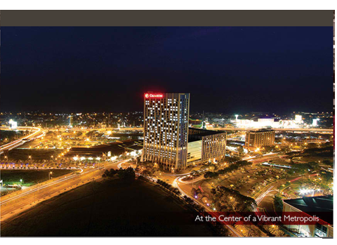
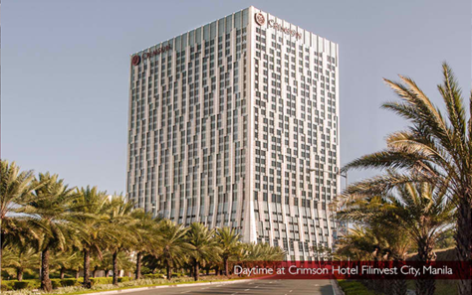
All Delegates MUST be housed at the OFFICIAL HOTEL. The Official Hotel is a 100-steps from the Tournament Venue.
Crimson Hotel Filinvest City, Manila, is your urban sanctuary housed in the most stunning tower complex ever to grace the metropolis. Our ironic architecture in the heart of the cosmopolitan city of Alabang,Muntinlupa makes us a landmark hotel in Southern manila we offer savvy business and leisure travelsers alike with an elegant lifestyles of live-work-shop-play seamlessly

Deluxe |  | -P5,500.00
Premier |  | -P6,000.00
Executive |  | -P8,500.00
All Rooms including buffet breakfast at Café Eight for up to 2 persons
Complimentary Wi-Fi internet access
Use of Fitness Center facilities and swimming pool
Daily shuttle service within Filinvest Corporate City based on Hotel’s schedule.

AIRPORT TRANSFER

In collaboration with travel & tours agency, Organizing Committee has organized a complete transportation service, useful for all the people who will join the HAYASHIHA SHITORYUKAI 3RD ASIA PACIFIC CHAMPIONSHIP KARATEDO & KOBUDO.

Types of Vehicles |  | No.of Pax |  | Airport Transfer |  | PHP |  | USD
CAR |  | 1-3 |  | NAIA-Hotel |  | PHP.2000 |  | USD45
TOYOTA VAN |  | 4-6 |  | NAIA-Hotel |  | PHP.3500 |  | USD80
MERCEDES BENZ VAN |  | 7-9 |  | NAIA-Hotel |  | PHP.4500 |  | USD100
COACH |  | 10-35 |  | NAIA-Hotel |  | PHP.10,000 |  | USD250

Buses/coaches will be arrangefree of charge during 2-day competition for the delegates who have made their hotel booking through the organizing committee only,

THE RESERVATION DEADLINE IS 15TH JUNE 2014

OFFICIAL TRAVEL AGENCY/TOUR
They will contacting you by our official travel agency
GOOD VOYAGE TRAVEL AND TOURS
73-12th Avenue Murphy Cubao Quezon City
Contact No: 6302-463-5144
Mobile number:
09048-876-2306
0917-620-2366
Email address:
goodvoyagetraveltours@yahoo.com

