2019
Nippon Karate-do Hayashi-Ha Shito Ryu Kai
Overseas Instructors Seminar and Dan exam
Details
Date/Time: Dec 9 (Mon) ～ Dec 13 (Fri) (Daily from 9:00 a.m. to 4:00p.m.)
Dan exam is Dec 13(Fri) in morning
Venue: Edion Arena Osaka ( Dai 2 Kyogijo & Judo Dojo)
Osaka City, Naniwa Ku, Naniwa Naka, 3-3-36
(Tel: 06-6631-0121)

Fee: USD$ 220 per person. Each country’s headquarters will pay by cash at the reception on the first day of the seminar according to the numbers of their participating members.

Application: Please fill in the attached form and send it to:
kuromon_san@yahoo.co.jp (Yamaguchi)

Chief Coordinator：International Instructors Chairman
Nagatomo Kenichiro（Cell phone：090-3717-4126）

Application deadline：No later than 5:00 p.m. on October 31（Thu）

※Please note:
①All participants/teams are responsible for arranging their own meals and accommodation.
②Participants must attend all seminars throughout the 5 days.
③Branches that have not paid their 2019 Hayashi-Ha Branch Membership Fees will be deemed as ineligible to participate in this seminar.
④Only include the names of those participating in the seminars in the application list.
⑤If members will be planning to take the Dan exam, please submit a list of 4dan or more. Dan exam 4dan ～ 8dan.

（Schedule）
 | Dec 9 (Mon) | Dec 10 (Tue) | Dec 11(Wed) | Dec 12 (Thu) | Dec 13 (Fri)
9.00～10.00 | Reception：Opening Ceremony | Stretching/Exercises | Stretching/Exercises | Kobudo Basics | Stretching/Exercises
10.00～12.00 | Basics | Kata | Kata | Kobudo | Dan Exam (4～8dan)
12.00～13.00 | Lunch | Lunch | Lunch | Lunch | Lunch and leader’s meeting
13.00～16.00 | Kata | Kata | Kata | Kobudo | Kata：Closing ceremony
Venue | Judo Dojo | Dai 2 Kyogijo | Dai 2 Kyogijo | Dai 2 Kyogijo | Judo Dojo

Map of the Osaka Edion Arena
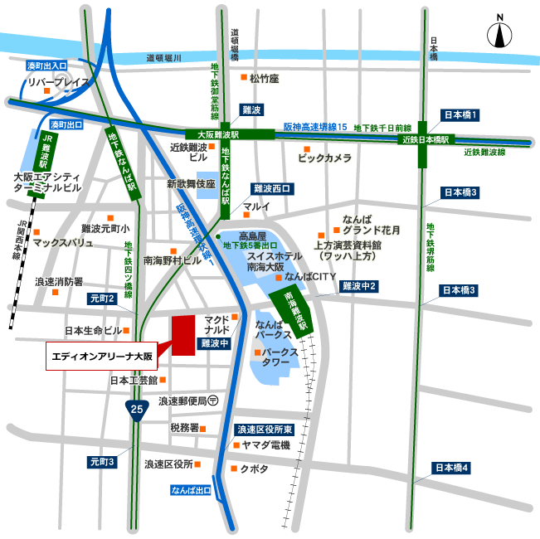
- 350m from the Namba Subway Station, Number 5 Exit
- 600m from Osaka Namba Station
- 250m from the South Exit of Nankai Namba Station
- 800m from the JR Namba Station
- 350m from the Osaka City Bus Service, Namba Bus Stop
- Roughly a 5 minute drive from the Namba Exit of the Hanshin (Motor) Expressway)

